IMPORTANT SAFETY INSTRUCTIONS

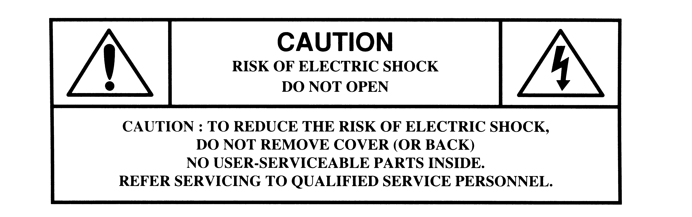
PLEASE READ ALL THESE INSTRUCTIONS REGARDING ANY ELECTRICAL/ELECTRONIC PRODUCTS PURCHASED FROM THE AMERICAN PRINTING HOUSE FOR THE BLIND. RETAIN THESE INSTRUCTIONS FOR FUTURE REFERENCE.

The exclamation point within an equilateral triangle is intended to alert the user to the presence of important operating and maintenance (servicing) instructions in the literature accompanying the product.


The lightning flash with arrowhead symbol within an equilateral triangle is intended to alert the user to the presence of un-insulated “dangerous voltage” within the product’s case that may be of sufficient magnitude to constitute a risk of electric shock. For the safety of everyone in your household, do not remove the product covering.
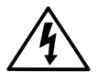

- Read instructions:

Read all safety and operating instructions before using the product.

- Retain instructions:

For future use, retain all safety and operating instructions for each APH product.

- Heed warnings:

Adhere to all warnings on each APH product and in the operating instructions.

- Follow instructions:

Follow all operation and user instructions.

- Cleaning:
If the product is plugged into an electrical outlet, unplug the unit before cleaning. Use only a clean dry cloth to remove dust. Do not use any liquid or aerosol cleaners. If necessary, use only a lightly water-dampened cloth for cleaning.

- Attachments:
If the APH product uses attachments, use ONLY the items designated for that product. Do not use attachments that are not designed for that product, or they might cause hazards.

- Water and moisture:
Do not use this or any APH product near water—for example, near bathtubs, washbowls, kitchen sinks, or laundry facilities. Avoid using this or any electrical product in any area that has wet floors, such as wet basements, swimming pools and any other wet areas. To prevent damage from condensation moisture that might develop if the unit was stored in a cool or cold area, allow the unit to come to room temperature for at least 2 hours before using.

- Product placement and use:
Do not place this or any product on an unstable surface. The product may fall, causing injury to a child or adult, and/or cause serious damage to the product.

- Ventilation:
Slots and openings in a device provide ventilation and ensure proper operation of the device without overheating. These openings must not be blocked or covered during operation. Any product that has ventilation openings should not be placed near or above any heat source such as a radiator or heat register. Do not place or stack other devices on top of this product such that the ventilation openings are blocked. Do not place this product into any type of enclosure such as a bookshelf or rack that will not allow for full ventilation as specified by the manufacturer.

- Grounding or polarization:
Any product sold by APH that has an AC power connection will meet all current safety standards. When a product is equipped with a polarized plug, one of the blades of the plug is wider than the other one. This type of plug will fit into the power outlet only one way. If you are unable to insert the plug fully into the outlet, try reversing the plug. If the plug fits “loosely” within the outlet, overheating may occur and become a fire hazard. Contact a qualified electrician to replace the loose or worn-out outlet.

- Power cord protection:
Route or arrange power cords so they are not likely to be walked-on or pinched. Note in particular the condition of the power cord at the plug body juncture and at the point where it exits the product. Damage to the power cord may cause a fire or shock hazard. When unplugging the power cord, do not pull on the cord to remove the plug, pull on the plug body and remove it carefully.

- Lightning:
For added protection of your APH product during lightning storms or when the device is left unattended for a long period of time, unplug the device from the AC outlet and telephone line (if used). This will prevent damage to the product due to lightning and line surges.

- Magnetic field hazards:
Some APH electronic products use or generate magnetic fields. Other magnetic fields may cause interference with the proper operation of the product. Do not bring any device that uses magnetic storage (hard drives or diskettes) near other magnetic field sources, or data damage/loss may occur. Other magnetic field sources include magnets, loudspeaker systems, electric motors, or any other devices that generate short distance magnet fields.

- Personal protection:
Do not walk or drive with the volume set too loud to hear other necessary sounds. Proper volume adjustment will prevent hearing damage during prolonged use of the device.

- Battery safety warnings:
Be sure to observe the following warnings to prevent accidents such as burns, fires due to leakage, over-heating, combustion, or explosion of the battery.

- Only use the specified battery that was included with the APH product. Replacement rechargeable battery packs and cells are available from APH.

- Do not expose batteries to fire or any source of heat.

- Do not disassemble the battery.

- Do not mix different types of batteries within a product.

- Do not charge or use the battery if it appears to be damaged or leaking.

- Discontinue charging a battery if it gives off extreme heat or a burning odor.

- Charging or using the battery in inappropriate devices can cause an explosion or fire, resulting
in personal injury and/or equipment damage.

- Do not use metal objects to insert batteries. This may short out the battery, causing burns and damage to the product.

- Do not subject the battery or batteries to physical shock such as being dropped or smashed.

- Do not use wet or abnormal appearing batteries.

- If any battery has become defective and leaked fluid, discard it promptly and carefully.

- If battery fluid leaks on your body or clothing, flush the area with plenty of water.

- If leaked battery fluid gets into your eyes, immediately rinse your eyes with clean water and seek medical
attention. Do not rub your eyes!

- Service:

- Do not disassemble, attempt to repair, or modify any APH product. There are no user serviceable components within these products.

- Whenever a problem arises with an APH product that cannot be resolved with any suggestions within the owner’s manual, please return the product to APH for qualified service.

FCC INFORMATION

All products sold by APH meet FCC approval.

